How to Access Windows Remote Desktop Over the Internet
We’ve covered several solutions for accessing your desktop remotely over the Internet, including TeamViewer and VNC. However, if you have a Professional edition of Windows, you already have Windows Remote Desktop installed.
By default, Windows Remote Desktop will only work on your local network. To access Remote Desktop over the Internet, you’ll need to use a VPN or forward ports on your router.
Before you continue, enable Remote Desktop on your computer and ensure you can access it from other computers on your local network.

Set Up a VPN
If you create a virtual private network (VPN), you won’t have to expose the Remote Desktop server directly to the Internet. Instead, you’ll first have to join your computer to the VPN. Your remote computer will act as if it’s part of the same local network as the computer running the Remote Desktop server. This will allow you to access Remote Desktop and other services only exposed on your local network.
There are a number of VPN applications you can use to create your own VPN, from complicated servers you configure by hand to easy-to-use graphical applications. We recommend LogMeIn Hamachi – download and install it on the computer you want to Remote Desktop to. Click here for more information on setting up Hamachi.
Once you’ve created an account, you can log into Hamachi on another computer and join both computers onto the same “Hamachi network.” They’ll act as if they’re connected directly, even if you’re doing this over the Internet.
You can now use the Remote Desktop Connection application on your computer to connect to the Remote Desktop server. Use the IPv4 address of the other computer, which is displayed in the Hamachi window while you’re connected.
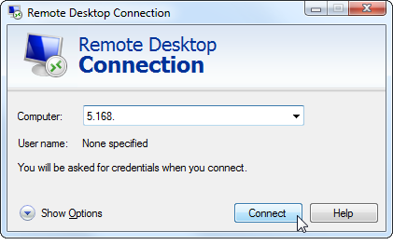

Forward TCP Port 3389
You can also skip the VPN and expose the Remote Desktop server directly to the Internet. If you do this, ensure you have strong passwords set up on your computer. You wouldn’t want malicious people logging into your computer remotely.
We’ll go over the process quickly here. For more detailed help, read our in-depth guide to port forwarding. If you follow that guide, ensure you forward TCP port 3389 to the computer running Remote Desktop.
First, locate the IP address of the computer running Remote Desktop. On the computer running Remote Desktop, open the Control Panel, click View network status and tasks, and click the name of your current connection to the right of Connections. Click the Details button and note the number displayed to the right of IPv4 Address. (Click here for more detailed step-by-step instructions to find your computer’s IP address.)
Next, access your router’s web interface. If you don’t know its address, it’s probably the same as the “IPv4 Default Gateway” address in the Network Connection Details window. Plug this address into your web browser’s address bar to access the router’s web interface.
Log into the router and locate the Port Forwarding section. Forward TCP port 3389 to the IPv4 address you located earlier.
You can now log into Remote Desktop over the Internet – connect to your network’s external IP address, also known as its public IP address.
If you’ve forwarded ports, you may want to set up a dynamic DNS service so you can always connect, even if your network’s IP address changes. You may also want to set up a static IP address on the computer running the Remote Desktop server. This will ensure that the computer’s internal IP address won’t change – if it does, you’ll have to change your port forwarding configuration.

